CURICULUM VETA FOR
ASST. PROF. DR. ENG. DHIA AHMED ALAZAWI

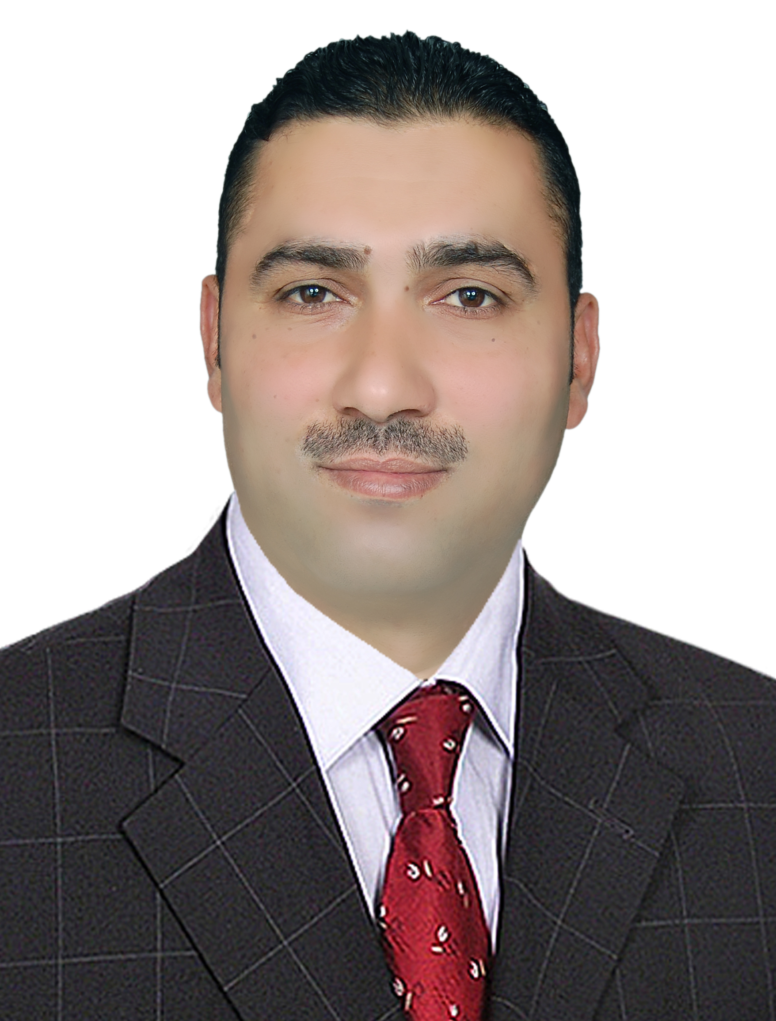
المعلومات الشخصية
الاسم : ضياء احمد صلال
محل وتاريخ الولادة : العراق , 1975
الجنسية : عراقية
العنوان : العراق / ديالى / بعقوبة /الاوقاف
رقم الهاتف : 7704850700
الايميل :
dhia.alazawi2@mail.dcu.ie ,
dhia.alazawi2@engineering.uodiyala.edu.iq

بلاد الدراسة : العراق , بريطانيا . ايرلندة

مساحات الاهتمام: الميكانيك التطبيقي , الاجهادات المتبقية , الامثلية

العمل والعمل الاكاديمي :
- ريس قسم الهدسة الميكانيكية (218-2021 )
- رئيس قسم هندسة المواد (2017)
- رئيس مجلس ادارة المكتب الاستشاري (2020)
- عضو المكتب الاستشاري (2016-2020)
- عضو المكتب العلمي (2012-2014)
- تدريس في كلية الهندسة وبمهام ادارية مختلفة(2001-2016)
- مهندس في مطار عباس ابن فرناس (2000)

الشهادات والالقاب الاكاديمية :
- بكلوريوس هندسة ميكانيكية / الجامهة التكنولوجية (1998)
- دبلوم عالي تطبيقات الحاسبات في الهندسة الميكاميكية / الجامعة التكنولوجية (1999)
- ماجستير في الهندسة الميكانيكية /جامعة بغداد
- دكتوراة في الهندسة الميكانيكية / جامعة بغداد , جامعن دبلن ستي يونيفرستي (20013)
- استاذ مساعد (2016)

البحوث المنشورة
The following papers were published as part of my professional and technical development:

[1] Dhia A. Alazawi†, Mazin Mahmood Yahya‡, Ali Jamal Khalid†, Numerical Vibration Analysis of Aluminum 6061-T6 Sandwich Plates with An Auxetic Core, Journal of Mechanical Engineering Research and, Developments ISSN: 1024-1752, Vol. 44, No. 6, pp. 281 – 290, Published Year 2021
[ 2] Dhia A. Alazawi, Ali Jamal Khalid, Nayyef ahmed Talib, Experimental and Numerical Analysis of Hygrothermal Effect on Applied Nano-Composite Material Under Bending Load, Journal of Mechanical Engineering Research and Developments ISSN: 1024-1752, Vol. 44, No. 6, pp. 59-70, Published Year 2021
[ 3 ] Dhia A. Alazawi†, Marwa R. Mohammad†*, Abdulrahman Th. Mohammad‡, Experimental study of the effects of vibration induced by water flow in spiral pipe, Journal of Mechanical Engineering Research and, Developments ISSN: 1024-1752, Vol. 44, No. 6, pp. 269 – 280, Published Year 2021
[ 4 ] Marwa R. Mohammad1*,1, Dhia A. Alazawi1 and Abdulrahman Th. Mohammad2, Case study on spiral solar collector performance with lens, AIMS Energy, 8(5): 859–868.
DOI: 10.3934/energy.2020.5.859 , Published: 11 September 2020
[ 5 ] Mohanad Nazhan Mohammed, Zaid S. Hammoudi, Dhia A. Alazawi, Strain analysis at flat surfaces of loaded members using digital image correlation technique, Periodicals of Engineering and Natural Sciences ISSN 2303-4521, Vol. 8, No. 3, August 2020, pp.1767-1785.
[ 6 ] Loay M. Mubarak†*, Ahmed Al-Samari‡, Dhia A. Alazawi‡, Marwa Fadel††, Comparison study of fuel consumption and emissions of HEVs and conventional vehicle in Iraq using real-world cycle, Journal of Mechanical Engineering Research and Developments, Vol. 43, No. 5, pp. 185-203, Published Year 2020
[ 7 ] Muammel M. Hanon1,2 · Nihal D. Salman1,2 · Dhia A. Alazawi3, Relative Deviation of Mass Flow Rate in Swirl Injectors due to the Engineering Tolerances: Experimental Study, International Journal of Aeronautical and Space Sciences, published 2018
[8 ] D. A. Alazawi, Feasibility and Optimization of Electrochemical Machining for 6061 Aluminum alloy Parameters , Diyala Journal of Engineering Science, in publishing 2017.

[9] D. A. Alazawi , Experimental Investigation on Electrochemical Machining Parameters , Diyala Journal of Engineering Science, in publishing 2017.

[ 3 ] M. I. Hameed, D. A. Alazawi , Z. S. Hammoudi, Finite Element Analysis of Steel and Composite Leaf Springs Under Static Loading, Conference Paper · January 2018

[ 10 ] Q. W. Ahmed1, D. A. Alazawi, * H. B. Mohammed, STUDY THE BEHAVIOR OF ELASTIC MODULUS FOR ZIGZAG AND ARMCHAIR SINGLE WALL CARBON NANOTUBE STRUCTURE WITH FEM, Jornal of Engineering and Development, in publishing 2016.

[ 11 ] D. A. Alazawi 1, B. M. Hussein2, L.E.N. Ekpeni3, FATIGUE BEHAVIORA STUDY OF FERRITIC-MARTENSITIC CRYOGENICALLY TREATED USING 17Mn4 STEEL, Second Engineering Scientific Conference ,College of Engineering –University of Diyala, 16-17 December. ISSN 1999-8716, 2015, pp. 731-739

[12 ] Sami A. A., Adel K. M., Dhia A. S., K. Y. Benyounis, Olabi A. G., Evaluation of the Mechanical Properties by Computational and Experimental Techniques in High Power Laser Welding of Dissimilar Materials, International Journal of Enhanced Research in Science Technology & Engineering, ISSN: 2319-7463 Vol. 3 Issue 11, November-2014, pp: (37-48)

[13] A. S. Dhia, K. M. Adel, A. G. Olabi1, Laser Welding Parameters of Dissimilar Materials, world Academy of Science, Engineering and Technology , p78 ,2013.

[14] D. A. Alazawi, K. Y. Benyounis, A. K. Alkayali, A. G. Olabi1, Effect of laser welding parameters on the welds bead geometries for dissimilar materials, 29th International Manufacturing Conference 29 - 30th august 2012, Belfast, UK.

[15] D. A. Alazawi, K. Y. Benyounis, A. K. Alkayali, A. G. Olabi1, Estimation of the Residual Stresses by Computational and Experimental techniques in laser welding of Dissimilar material, international Conference on advanced Manufacturing and Automation 28th -30th march, 2013, India .(paper acceptance)

[16] K.M. Adel1, A.S. Dhia2 and M.J. Ghazali 3 ,The Effect of Laser Surface Hardening on the Wear and Friction Characteristics of Aciculer Bainatic Ductile Iron, The International Conference on Advaces in Material and Processing Technologies (AMPT_2009), 26-29 October , , Faculty of Engineering, Universiti Kebangsaan Malaysia, 43600 Bangi, Selangor, Malaysia.

[17] Study the Effect of Produced Temperature due to Friction on the Behavior and Characteristics of the Dry Sliding Wear of the Acicular Bainitic Ductile Iron.,The first engineering Scientific Conference (FESC_ 2010) 22-23 October , , Faculty of Engineering, Universitiy Diyala .

[18] Wear Resistance Improvement of 41Cr Steel Alloy by Laser Surface Hardening, Diyala Journal of Engineering Science ,Faculty of Engineering, Universitiy Diyala , Vol. 01, No. 01, pp. 101-109 , December 2008.

[19] Enhancement of Dry Sliding Wear Characteristics and Refinement the Microstructure of Ck45 Steel by Laser Surface Processing, Diyala Journal of Engineering Science ,Faculty of Engineering, Universitiy Diyala, accepted 2008.

